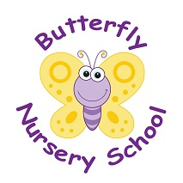
Butterfly Nursery School
Church Road
Horne
Surrey
RH6 9LA
01342 843655
POLICY: Waste Management

At Butterfly Nursery School we value our environment and in order to keep our earth safe and healthy for our children we closely monitor and management of our waste and its disposal in accordance with local authority requirements.

Staff are made aware of the need to minimise energy waste and the nursery uses appropriate measures to save energy, including:
- Turning off lights when not in use
- Not leaving equipment on standby
- Un plugging all equipment at the end of its use/the day

The nursery recycles paper waste at paper banks and ensures that where possible other sources of waste are recycled to reduce the effect on the environment.

We assess our nursery’s impact on the environment on a regular basis and place procedures in place to counteract this impact.

This policy is reviewed annually and is carefully considered in the best interests of the children, nursery and the environment.

This policy was adopted on | Signed on behalf of the nursery | Date disseminated to staff | Date for review

